Experiment 01 Prelab

Nicholas Pun

27872167

1. Consider the circuit in Fig. 2 where the function generator is set to produce a square wave such that the voltage applied alternates between +1V and 0 every 1000s. How long does it take for the voltage across the capacitor to reach 10mV after the voltage suddenly goes from +1V to zero?

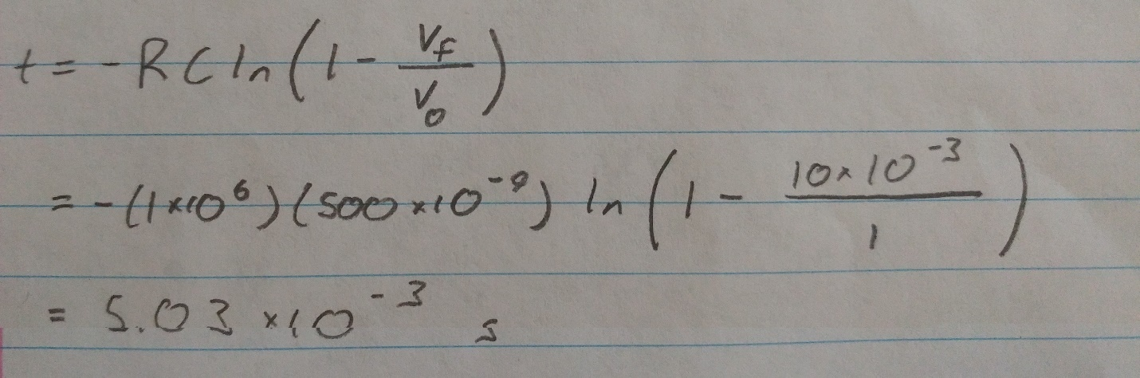

1. Suppose the 1M Ohm resistor in Fig. 2 is replaced with a 10K Ohm resistor. How long does it take for the voltage across the capacitor reach 10mV after the voltage from the function generator drops from +1V to zero?

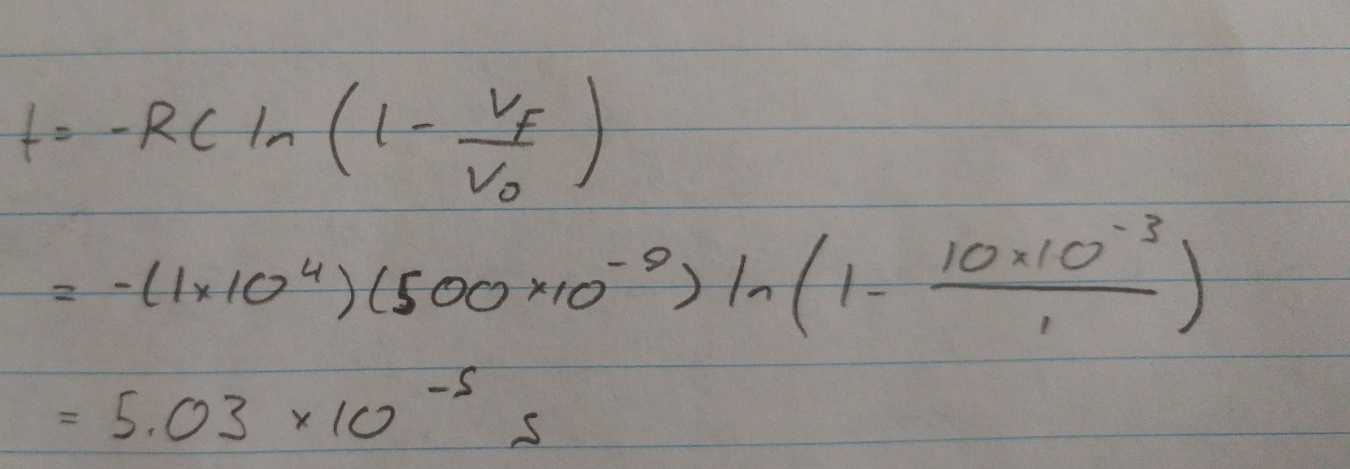

1. From the values in Fig. 1 suppose the function generator produces a sinusoidal output with an amplitude of +1V and a frequency f equal 50Hz. Sketch the voltage output from the generator, the voltage across the capacitor and the voltage across the resistor, all as a function of time.

